You Shall Weep No More
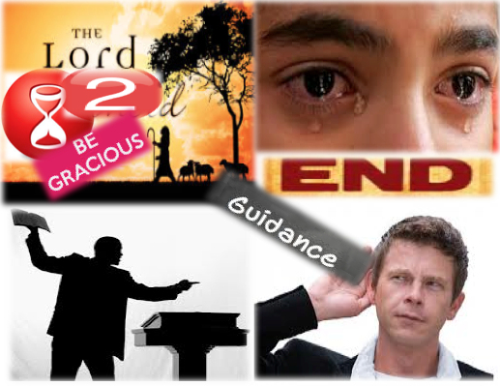

The Way Church
Brother David S. Wilson
November 30, 2014

Message Title: You Shall Weep No More
Message Truth: The Lord will hear your cry, He is gracious to you and will bring forth teachers, and His Word will guide your every step. You must respond.
Scripture: Isaiah 30:18-21

18 Therefore the Lord will wait, that He may be gracious to you;
And therefore He will be exalted, that He may have mercy on you.
For the Lord is a God of justice;
Blessed are all those who wait for Him.

19 For the people shall dwell in Zion at Jerusalem;
You shall weep no more.
He will be very gracious to you at the sound of your cry;
When He hears it, He will answer you.

20 And though the Lord gives you
The bread of adversity and the water of affliction,
Yet your teachers will not be moved into a corner anymore,
But your eyes shall see your teachers.

21 Your ears shall hear a word behind you, saying,
“This is the way, walk in it,”
Whenever you turn to the right hand
Or whenever you turn to the left.

____________________________________________________________

18 Therefore the Lord will wait, that He may be gracious to you;
And therefore He will be exalted, that He may have mercy on you.
For the Lord is a God of justice;
Blessed are all those who wait for Him.

- The Lord waits to be gracious to you.
  - He will be exalted.
  - He is merciful.
  - He is just.
  - He commands patience.

19 For the people shall dwell in Zion at Jerusalem;
You shall weep no more.
He will be very gracious to you at the sound of your cry;
When He hears it, He will answer you.

- The weeping will end, for those who dwell in Zion.
  - The Lord is very gracious.
  - The Lord awaits your cry.
  - The Lord will hear.
  - The Lord will answer.

20 And though the Lord gives you
The bread of adversity and the water of affliction,
Yet your teachers will not be moved into a corner anymore,
But your eyes shall see your teachers.

- Your teachers will teach.
  - Your teacher will teach during adversity and affliction.
  - They will be moved out of the corner.
  - Your eyes will be opened.

21 Your ears shall hear a word behind you, saying,
“This is the way, walk in it,”
Whenever you turn to the right hand
Or whenever you turn to the left.

- You will hear the guidance of the Lord.
  - Truth shall be spoken.
  - You are expected to walk in the truth.
  - God will redirect.

