Warning Signs
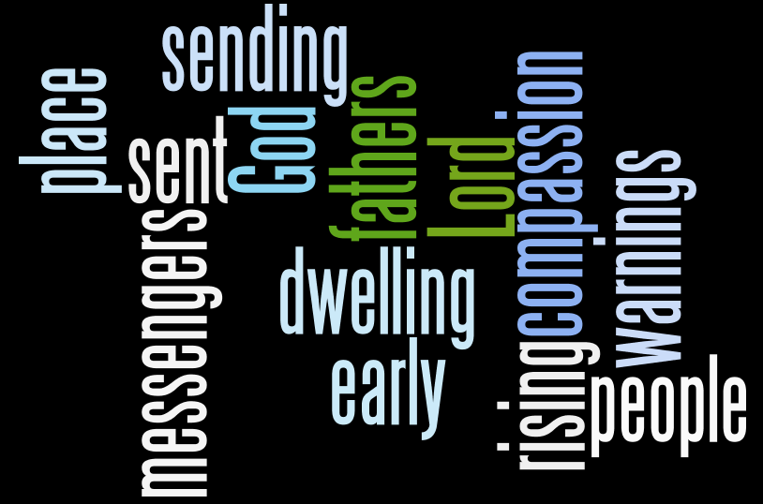

The Way Church
David S. Wilson
November 8, 2014

Message Title: Warning Signs
Message Truth: God sends us warning signs early in our circumstance because He has compassion on us.
Scripture: 2 Chronicles 36:15
15 And the Lord God of their fathers sent warnings to them by His messengers, rising up early and sending them, because He had compassion on His people and on His dwelling place.
Break It Down:
- The Lord God sends WARNINGS.
15 And the Lord God of their fathers sent warnings to them by His messengers, rising up early and sending them, because He had compassion on His people and on His dwelling place.
The alarm sounds.
-His Word
-His Children
-His Consequences
-His Testimony

- The Lord God sends the warnings EARLY.
15 And the Lord God of their fathers sent warnings to them by His messengers, rising up early and sending them, because He had compassion on His people and on His dwelling place.
Timing is everything in your relationship with Jesus.
Genesis 4 Now Adam knew Eve his wife, and she conceived and bore Cain, and said, “I have acquired a man from the Lord.” 2 Then she bore again, this time his brother Abel. Now Abel was a keeper of sheep, but Cain was a tiller of the ground. 3 And in the process of time it came to pass that Cain brought an offering of the fruit of the ground to the Lord. 4 Abel also brought of the firstborn of his flock and of their fat. And the Lord respected Abel and his offering, 5 but He did not respect Cain and his offering. And Cain was very angry, and his countenance fell. 6 So the Lord said to Cain, “Why are you angry? And why has your countenance fallen? 7 If you do well, will you not be accepted? And if you do not do well, sin lies at the door. And its desire is for you, but you should rule over it.”

- The Lord God sends the warnings because He has COMPASSION.
15 And the Lord God of their fathers sent warnings to them by His messengers, rising up early and sending them, because He had compassion on His people and on His dwelling place.
- Isaiah 3:18 Therefore the Lord will wait, that He may be
gracious to you;
And therefore He will be exalted, that He may have mercy on you. For the Lord is a God of justice; Blessed are all those who wait for Him.
- James 5:11 Indeed we count them blessed who endure. You
have heard of the perseverance of Job and seen the end intended by the Lord—that the Lord is very compassionate and merciful.

C. Nehemiah 9:17 They refused to obey,
And they were not mindful of Your wonders
That You did among them.
But they hardened their necks,
And in their rebellion
They appointed a leader
To return to their bondage.
But You are God,
Ready to pardon,
Gracious and merciful,
Slow to anger,
Abundant in kindness,
And did not forsake them.

Read Deuteronomy 28 the entire chapter over and over again!

Deuteronomy 28:47 “Because you did not serve the Lord your God with joy and gladness of heart, for the abundance of everything, 48 therefore you shall serve your enemies, whom the Lord will send against you, in hunger, in thirst, in nakedness, and in need of everything; and He will put a yoke of iron on your neck until He has destroyed you.

