To Be Glorified

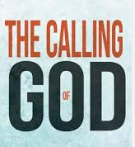
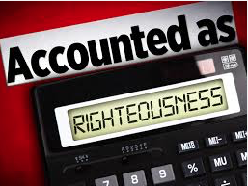

theway church
david s. wilson
June 5, 2016

Romans 8:28-30 And we know that all things work together for good to those who love God, to those who are the called according to His purpose. 29 For whom He foreknew, He also predestined to be conformed to the image of His Son, that He might be the firstborn among many brethren. 30 Moreover whom He predestined, these He also called; whom He called, these He also justified; and whom He justified, these He also glorified.

The beauty of this scripture rests in the message God sends to each of us who believe. God predestined us, He called us, He justified us, and He glorified us. This blew me away this week. He glorifies me. This is beautiful. God predestined all of us for a cross. He called all of us to an opportunity to be saved and He wills that none should perish, but instead all would come to the saving knowledge of Jesus Christ (2 Peter 3:9).

- God predestined us for a cross.
  - Ephesians 1:5 having predestined us to adoption as sons by Jesus Christ to Himself, according to the good pleasure of His will, 6 to the praise of the glory of His grace, by which He made us accepted in the Beloved.
  - 2 Peter 3:9 The Lord is not slack concerning His promise, as some count slackness, but is longsuffering toward us, not willing that any should perish but that all should come to repentance.

- God called us to salvation.
John 6:44-45 No one can come to Me unless the Father who sent Me draws him; and I will raise him up at the last day. 45 It is written in the prophets, ‘And they shall all be taught by God.’ Therefore everyone who has heard and learned from the Father comes to Me.

- God justified us.
  - Justified-Dikaioō (dē-kī-o'-ō) to render righteous or such he ought to be
  - Romans 5:1 Therefore, having been justified by faith, we have peace with God through our Lord Jesus Christ,
- God glorifies us.
  - Glorify-Doxazō (do-ksä'-zō) to praise, extol, magnify, celebrate
  - To impart glory to something
  - Render it excellent

