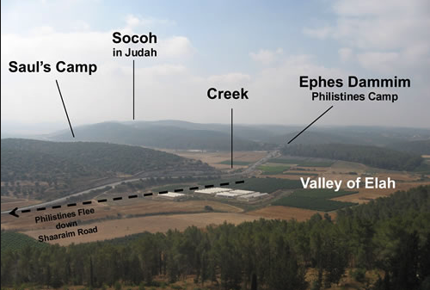
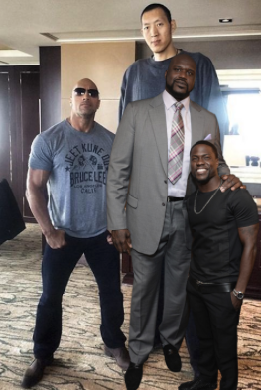

This week is all about you!
This week we are asking you to bring the questions to Sunday school. We are asking for this week to be a time where you bring your heart, worship, and study as we open up the class to discuss what God spoke to YOU from the message. This week you could be looking through three different lenses, which one are you looking through?

(You do not have to have as many as are listed)

Key Words:
_______________:
__________________________________________________________________________________________________________________________________________________________________________________________________________________________________________
_______________:
__________________________________________________________________________________________________________________________________________________________________________________________________________________________________________
_______________:
__________________________________________________________________________________________________________________________________________________________________________________________________________________________________________
_______________:
__________________________________________________________________________________________________________________________________________________________________________________________________________________________________________
_______________:
__________________________________________________________________________________________________________________________________________________________________________________________________________________________________________

Your Questions (And Answers)
- ________________________________________________________________________________________________________________________________________________
__________________________________________________________________________________________________________________________________________________________________________________________________________________________________________
- ________________________________________________________________________________________________________________________________________________
__________________________________________________________________________________________________________________________________________________________________________________________________________________________________________
- ________________________________________________________________________________________________________________________________________________
__________________________________________________________________________________________________________________________________________________________________________________________________________________________________________
- ________________________________________________________________________________________________________________________________________________
__________________________________________________________________________________________________________________________________________________________________________________________________________________________________________
- ________________________________________________________________________________________________________________________________________________
__________________________________________________________________________________________________________________________________________________________________________________________________________________________________________
Are you looking through the lens of Saul, Goliath, or David? What does it mean to be looking through this lens? Which one is the correct lens and do you usually look through this lens?
__________________________________________________________________________________________________________________________________________________________________________________________________________________________________________

What changed in Saul?
__________________________________________________________________________________________________________________________________________________________________________________________________________________________________________
How/Why does our lens or perspective change? Can we keep looking through the correct lens everyday? If yes, how? If no, why not?
__________________________________________________________________________________________________________________________________________________________________________________________________________________________________________
(Luke and Joah’s )™ ⇑

