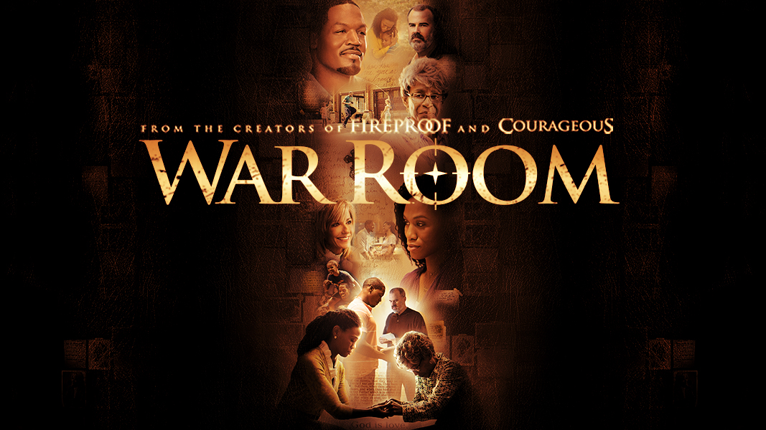

Schedule
July 22, 2015 War Room Introduction
Ephesians 1:15-23
Discussion: Questions 1-8
Homework: Questions 1-4

July 29, 2015 Session 1
Honest Evaluation pages 10-13
Video: “Luke Warm Coffee”
Homework: Day 1,2,3 pages 14-19

August 5, 2015 Session 2 Real Accountability pages 20-23
Video: “Weight Room”
Homework: Day 1,2,3 pages 24-29

August 12, 2015 Session 3 Living The Gospel pages 30-33
Video: “Gospel and Grace”
Homework: Day 1,2,3 pages 34-39

August 19, 2015 Session 4 Victory Accomplished pages 40-43
Video: “Kicking Out the Devil”
Homework: Day 1,2,3 pages 44-49

August 26, 2015 Session 5 Impacted by Grace pages 50-53
Video: “Tony’s Apology”
Homework: Day 1,2,3 pages 54-59

August 28, 2015 Movie Night Carmike Cinemas “War Room”

