Preach The Gospel

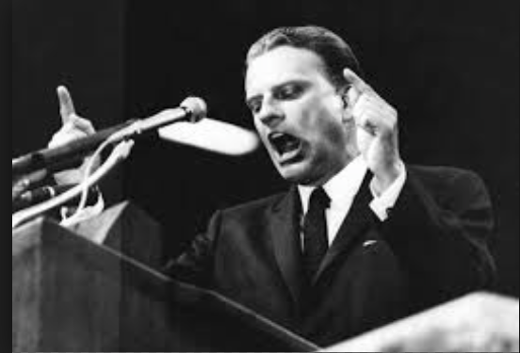

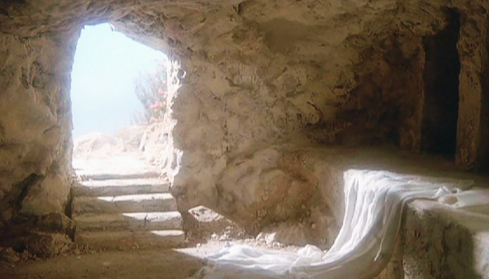

theway church
david s. wilson
April 24, 2016

1. Preach The Gospel

Romans 1:16-17
16 For I am not ashamed of the gospel of Christ, for it is the power of God to salvation for everyone who believes, for the Jew first and also for the Greek. 17 For in it the righteousness of God is revealed from faith to faith; as it is written, “The just shall live by faith.”

2. Preach The Gospel

1 Corinthians 15:1-8
Moreover, brethren, I declare to you the gospel which I preached to you, which also you received and in which you stand, 2 by which also you are saved, if you hold fast that word which I preached to you—unless you believed in vain. 3 For I delivered to you first of all that which I also received: that Christ died for our sins according to the Scriptures, 4 and that He was buried, and that He rose again the third day according to the Scriptures, 5 and that He was seen by Cephas, then by the twelve. 6 After that He was seen by over five hundred brethren at once, of whom the greater part remain to the present, but some have fallen asleep. 7 After that He was seen by James, then by all the apostles. 8 Then last of all He was seen by me also, as by one born out of due time.

3. Preach the Gospel
Acts 10:42-44
42 And He commanded us to preach to the people, and to testify that it is He who was ordained by God to be Judge of the living and the dead. 43 To Him all the prophets witness that, through His name, whoever believes in Him will receive remission of sins.” 44 While Peter was still speaking these words, the Holy Spirit fell upon all those who heard the word.

