On Mission
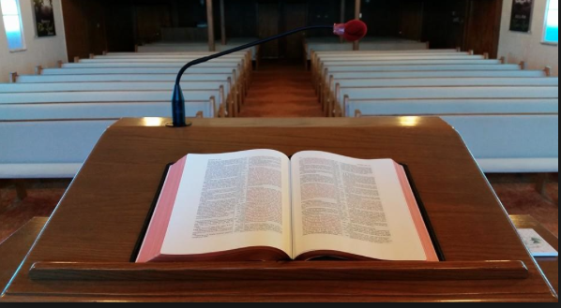

theway church
david wilson
June 19, 2016
The mission of theway church is to impact the community by teaching and training individuals that Jesus Christ is the way, the truth, and the life.

How do we impact this community?
-teaching
-training

We are a Jesus Christ Educational Facility. We are here to teach and train individuals that Jesus Christ is the way the truth and the life.

Our Family Scripture is John 14:6, “Jesus said to him, “I am the way, the truth, and the life. No one comes to the Father except through Me.””

How do we accomplish our mission?

There are four columns on which we must build:

1. Preach the Word of God without compromise.
Romans 10:14-15 How then shall they call on Him in whom they have not believed? And how shall they believe in Him of whom they have not heard? And how shall they hear without a preacher? 15 And how shall they preach unless they are sent? As it is written: “How beautiful are the feet of those who preach the gospel of peace, Who bring glad tidings of good things!”

2. Pray without ceasing for the mission of the church.
Romans 1:9 For God is my witness, whom I serve with my spirit in the gospel of His Son, that without ceasing I make mention of you always in my prayers,

3. Teach disciples how to be soldiers for Christ.
Ephesians 4:11-16 And He Himself gave some to be apostles, some prophets, some evangelists, and some pastors and teachers, 12 for the equipping of the saints for the work of ministry, for the edifying of the body of Christ, 13 till we all come to the unity of the faith and of the knowledge of the Son of God, to a perfect man, to the measure of the stature of the fullness of Christ; 14 that we should no longer be children, tossed to and fro and carried about with every wind of doctrine, by the trickery of men, in the cunning craftiness of deceitful plotting, 15 but, speaking the truth in love, may grow up in all things into Him who is the head—Christ— 16 from whom the whole body, joined and knit together by what every joint supplies, according to the effective working by which every part does its share, causes growth of the body for the edifying of itself in love.

4. DO the work of the ministry.
2 Timothy 4:5 But you be watchful in all things, endure afflictions, do the work of an evangelist, fulfill your ministry.

