His Eyes On You
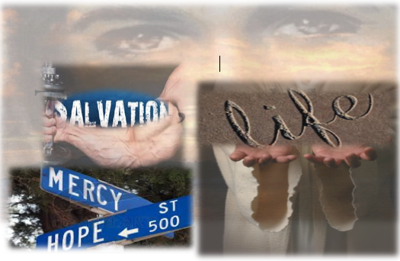

The Way Church
Brother David S. Wilson

Message Title: All Eyes On You
Message Truth: Jesus is looking down upon us, He is ready to provide us with salvation, strength and everything we need to sustain us, delivering mercy and expecting our hope to be in Him.

Psalm 33:13-22
13 The Lord looks from heaven; He sees all the sons of men.14 From the place of His dwelling He looks On all the inhabitants of the earth; 15 He fashions their hearts individually; He considers all their works. 16 No king is saved by the multitude of an army; A mighty man is not delivered by great strength. 17 A horse is a vain hope for safety; Neither shall it deliver any by its great strength. 18 Behold, the eye of the Lord is on those who fear Him, On those who hope in His mercy, 19 To deliver their soul from death, And to keep them alive in famine. 20 Our soul waits for the Lord; He is our help and our shield. 21 For our heart shall rejoice in Him, Because we have trusted in His holy name. 22 Let Your mercy, O Lord, be upon us, Just as we hope in You.

1. Who Sees You? vv13-15
A. Jesus looks from heaven. vv13-14
B. Jesus sees the children of God. v13
C. Jesus sees the lost. v14
D. Jesus fashions our hearts. v15
E. Jesus is a fruit inspector. v15

2. What do you rely on for strength and salvation?
A. No army is big enough. v16
B. No man is mighty enough. v16
C. No beast is strong enough. v17

3. Who is the sustainer of your life? vv18-19
A. Jesus sees those who fear Him. v18
B. Jesus gives attention to those who hope in Him. v18
C. Jesus saves the soul. v19
D. Jesus provides for our physical needs. v19

4. What is your soul doing?
A. Jesus is our help in time of need. v20
B. Jesus is our shield of protection. v20
C. Jesus expects our heart. v21
D. Jesus expects our trust to mean something. v22
E. Jesus delivers mercy and expects hope. v22

May Jesus Christ reveal to you each and everyday how powerful He is and how much He loves you and desires your heart. The invitation is open; today you can know Jesus in an intimate way. You can walk with Him in a relationship that will empower your steps and direct your path. I pray you do not do what you and many others have been doing for weeks, hearing the Word of God, gaining more knowledge of Him, but never coming to a point of surrender so you can truly KNOW Him. Today, the altar is open, you can surrender today, and be different or you can leave today the same way you came. I pray you chose to follow Him.

