He Was Forsaken So You Never Will Be
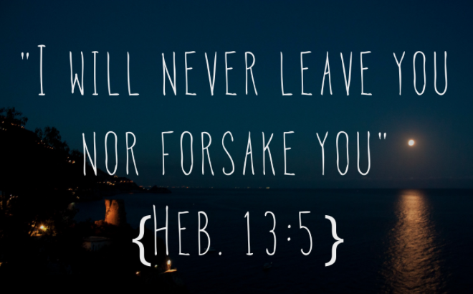

The Way Church
Brother David S. Wilson
January 18, 2015

Message Title: He Was Forsaken So You Never Will Be
Message Truth: Jesus was forsaken by family, and friends so that you will never be forsaken.
Scripture: Hebrews 13:5, Matthew 13:53-58, John 7:5
Matthew 26:36-56, Matthew 27:33-46,
Matthew 6:14-15
Hebrews 13:5

5 Let your conduct be without covetousness; be content with such things as you have. For He Himself has said, “I will never leave you nor forsake you.”6 So we may boldly say:
“The Lord is my helper;
I will not fear.
What can man do to me?”

Forsaken:
- abandon, desert
  - leave in straits, leave helpless
  - totally abandoned, utterly forsaken
to leave behind among, to leave surviving

- Jesus was forsaken by His Family.
Matthew 13:53-58
53 Now it came to pass, when Jesus had finished these parables, that He departed from there. 54 When He had come to His own country, He taught them in their synagogue, so that they were astonished and said, “Where did this Man get this wisdom and these mighty works? 55 Is this not the carpenter’s son? Is not His mother called Mary? And His brothers James, Joses, Simon, and Judas? 56 And His sisters, are they not all with us? Where then did this Man get all these things?” 57 So they were offended at Him.
But Jesus said to them, “A prophet is not without honor except in his own country and in his own house.” 58 Now He did not do many mighty works there because of their unbelief.

John 7:5
5 For even His brothers did not believe in Him.

- Jesus was forsaken by His Friends.
Matthew 26:36-56
36 Then Jesus came with them to a place called Gethsemane, and said to the disciples, “Sit here while I go and pray over there.” 37 And He took with Him Peter and the two sons of Zebedee, and He began to be sorrowful and deeply distressed. 38 Then He said to them, “My soul is exceedingly sorrowful, even to death. Stay here and watch with Me.” 39 He went a little farther and fell on His face, and prayed, saying, “O My Father, if it is possible, let this cup pass from Me; nevertheless, not as I will, but as You will.” 40 Then He came to the disciples and found them sleeping, and said to Peter, “What! Could you not watch with Me one hour? 41 Watch and pray, lest you enter into temptation. The spirit indeed is willing, but the flesh is weak.” 42 Again, a second time, He went away and prayed, saying, “O My Father, if this cup cannot pass away from Me unless I drink it, Your will be done.” 43 And He came and found them asleep again, for their eyes were heavy. 44 So He left them, went away again, and prayed the third time, saying the same words. 45 Then He came to His disciples and said to them, “Are you still sleeping and resting? Behold, the hour is at hand, and the Son of Man is being betrayed into the hands of sinners. 46 Rise, let us be going. See, My betrayer is at hand.”47 And while He was still speaking, behold, Judas, one of the twelve, with a great multitude with swords and clubs, came from the chief priests and elders of the people. 48 Now His betrayer had given them a sign, saying, “Whomever I kiss, He is the One; seize Him.” 49 Immediately he went up to Jesus and said, “Greetings, Rabbi!” and kissed Him. 50 But Jesus said to him, “Friend, why have you come?”
Then they came and laid hands on Jesus and took Him. 51 And suddenly, one of those who were with Jesus stretched out his hand and drew his sword, struck the servant of the high priest, and cut off his ear. 52 But Jesus said to him, “Put your sword in its place, for all who take the sword will perish by the sword. 53 Or do you think that I cannot now pray to My Father, and He will provide Me with more than twelve legions of angels? 54 How then could the Scriptures be fulfilled, that it must happen thus?” 55 In that hour Jesus said to the multitudes, “Have you come out, as against a robber, with swords and clubs to take Me? I sat daily with you, teaching in the temple, and you did not seize Me. 56 But all this was done that the Scriptures of the prophets might be fulfilled.”
Then all the disciples forsook Him and fled.

- Jesus was forsaken by His Father.
Matthew 27:33-46
33 And when they had come to a place called Golgotha, that is to say, Place of a Skull, 34 they gave Him sour wine mingled with gall to drink. But when He had tasted it, He would not drink.35 Then they crucified Him, and divided His garments, casting lots, that it might be fulfilled which was spoken by the prophet: “They divided My garments among them, And for My clothing they cast lots.”36 Sitting down, they kept watch over Him there. 37 And they put up over His head the accusation written against Him: THIS IS JESUS THE KING OF THE JEWS. 38 Then two robbers were crucified with Him, one on the right and another on the left.39 And those who passed by blasphemed Him, wagging their heads 40 and saying, “You who destroy the temple and build it in three days, save Yourself! If You are the Son of God, come down from the cross.”41 Likewise the chief priests also, mocking with the scribes and elders, said, 42 “He saved others; Himself He cannot save. If He is the King of Israel, let Him now come down from the cross, and we will believe Him. 43 He trusted in God; let Him deliver Him now if He will have Him; for He said, ‘I am the Son of God.’” 44 Even the robbers who were crucified with Him reviled Him with the same thing. Jesus Dies on the Cross 45 Now from the sixth hour until the ninth hour there was darkness over all the land. 46 And about the ninth hour Jesus cried out with a loud voice, saying, “Eli, Eli, lama sabachthani?” that is, “My God, My God, why have You forsaken Me?”

- Jesus is forsaken by you.
Matthew 6:14-15
14 “For if you forgive men their trespasses, your heavenly Father will also forgive you. 15 But if you do not forgive men their trespasses, neither will your Father forgive your trespasses.

We forsake Jesus and what He did on the cross when we refuse to forgive. You can forgive, if the Holy Spirit dwells within. You have heavens supply of forgiveness through the power of the Holy Spirit, your question today is will you use it?

