From Somebody to Daughter
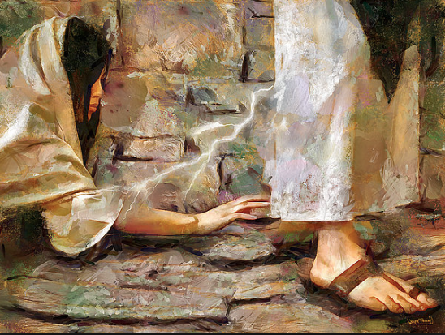

theway church
Sunday, January 24, 2016
David S. Wilson
Mark 5:21-43 New King James Version (NKJV)
A Girl Restored to Life and a Woman Healed
21 Now when Jesus had crossed over again by boat to the other side, a great multitude gathered to Him; and He was by the sea. 22 And behold, one of the rulers of the synagogue came, Jairus by name. And when he saw Him, he fell at His feet 23 and begged Him earnestly, saying, “My little daughter lies at the point of death. Come and lay Your hands on her, that she may be healed, and she will live.” 24 So Jesus went with him, and a great multitude followed Him and thronged Him. 25 Now a certain woman had a flow of blood for twelve years, 26 and had suffered many things from many physicians. She had spent all that she had and was no better, but rather grew worse. 27 When she heard about Jesus, she came behind Him in the crowd and touched His garment. 28 For she said, “If only I may touch His clothes, I shall be made well.” 29 Immediately the fountain of her blood was dried up, and she felt in her body that she was healed of the affliction. 30 And Jesus, immediately knowing in Himself that power had gone out of Him, turned around in the crowd and said, “Who touched My clothes?” 31 But His disciples said to Him, “You see the multitude thronging You, and You say, ‘Who touched Me?’” 32 And He looked around to see her who had done this thing. 33 But the woman, fearing and trembling, knowing what had happened to her, came and fell down before Him and told Him the whole truth. 34 And He said to her, “Daughter, your faith has made you well. Go in peace, and be healed of your affliction.”

Matthew 9:18-26 New King James Version (NKJV)
18 While He spoke these things to them, behold, a ruler came and worshiped Him, saying, “My daughter has just died, but come and lay Your hand on her and she will live.” 19 So Jesus arose and followed him, and so did His disciples. 20 And suddenly, a woman who had a flow of blood for twelve years came from behind and touched the hem of His garment. 21 For she said to herself, “If only I may touch His garment, I shall be made well.” 22 But Jesus turned around, and when He saw her He said, “Be of good cheer, daughter; your faith has made you well.” And the woman was made well from that hour.

Luke 8:40-48 New King James Version (NKJV)
40 So it was, when Jesus returned, that the multitude welcomed Him, for they were all waiting for Him. 41 And behold, there came a man named Jairus, and he was a ruler of the synagogue. And he fell down at Jesus’ feet and begged Him to come to his house, 42 for he had an only daughter about twelve years of age, and she was dying.
But as He went, the multitudes thronged Him. 43 Now a woman, having a flow of blood for twelve years, who had spent all her livelihood on physicians and could not be healed by any, 44 came from behind and touched the border of His garment. And immediately her flow of blood stopped. 45 And Jesus said, “Who touched Me?” When all denied it, Peter and those with him said, “Master, the multitudes throng and press You, and You say, ‘Who touched Me?’” 46 But Jesus said, “Somebody touched Me, for I perceived power going out from Me.” 47 Now when the woman saw that she was not hidden, she came trembling; and falling down before Him, she declared to Him in the presence of all the people the reason she had touched Him and how she was healed immediately. 48 And He said to her, “Daughter, be of good cheer; your faith has made you well. Go in peace.”

Be moved and shaken by the following:

- The woman’s condition. (Mark 5:25-26, Matthew 9:20, Luke 8:43)
Mark 5:25-26 Now a certain woman had a flow of blood for twelve years, 26 and had suffered many things from many physicians. She had spent all that she had and was no better, but rather grew worse.

- What the woman heard. (Mark 5:27)
Mark 5:27 When she heard about Jesus, she came behind Him in the crowd and touched His garment.

Mark 5:23 and begged Him earnestly, saying, “My little daughter lies at the point of death. Come and lay Your hands on her, that she may be healed, and she will live.”

- What the woman saw. (Mark 5:21-24)
Mark 5:21-24 Now when Jesus had crossed over again by boat to the other side, a great multitude gathered to Him; and He was by the sea. 22 And behold, one of the rulers of the synagogue came, Jairus by name. And when he saw Him, he fell at His feet 23 and begged Him earnestly, saying, “My little daughter lies at the point of death. Come and lay Your hands on her, that she may be healed, and she will live.” 24 So Jesus went with him, and a great multitude followed Him and thronged Him.

- What the woman believed. (Mark 5:28, 9:20-21, Luke 8:44)
Mark 5:28 For she said, “If only I may touch His clothes, I shall be made well.”

- What happened to her. (Mark 5:29, Luke 8:44)
Mark 5:29 Immediately the fountain of her blood was dried up, and she felt in her body that she was healed of the affliction.

- What Jesus knew. (Mark 5:30, Luke 8:46)
Mark 5:30 And Jesus, immediately knowing in Himself that power had gone out of Him, turned around in the crowd and said, “Who touched My clothes?”

- What was expected of her. (Mark 5:33-34, Luke 8:47-48)
Mark 5:33-34 But the woman, fearing and trembling, knowing what had happened to her, came and fell down before Him and told Him the whole truth. 34 And He said to her, “Daughter, your faith has made you well. Go in peace, and be healed of your affliction.”

