Find The Joy In Living

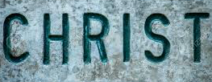

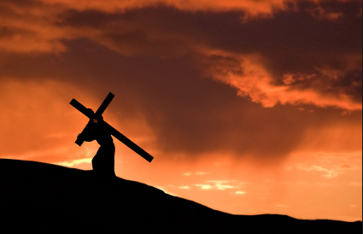

theway church
david s. wilson
May 15, 2016

Colossians 3:1-17
If then you were raised with Christ, seek those things which are above, where Christ is, sitting at the right hand of God. 2 Set your mind on things above, not on things on the earth. 3 For you died, and your life is hidden with Christ in God. 4 When Christ who is our life appears, then you also will appear with Him in glory. 5 Therefore put to death your members which are on the earth: fornication, uncleanness, passion, evil desire, and covetousness, which is idolatry. 6 Because of these things the wrath of God is coming upon the sons of disobedience, 7 in which you yourselves once walked when you lived in them. 8 But now you yourselves are to put off all these: anger, wrath, malice, blasphemy, filthy language out of your mouth. 9 Do not lie to one another, since you have put off the old man with his deeds, 10 and have put on the new man who is renewed in knowledge according to the image of Him who created him, 11 where there is neither Greek nor Jew, circumcised nor uncircumcised, barbarian, Scythian, slave nor free, but Christ is all and in all. 12 Therefore, as the elect of God, holy and beloved, put on tender mercies, kindness, humility, meekness, longsuffering; 13 bearing with one another, and forgiving one another, if anyone has a complaint against another; even as Christ forgave you, so you also must do. 14 But above all these things put on love, which is the bond of perfection. 15 And let the peace of God rule in your hearts, to which also you were called in one body; and be thankful. 16 Let the word of Christ dwell in you richly in all wisdom, teaching and admonishing one another in psalms and hymns and spiritual songs, singing with grace in your hearts to the Lord. 17 And whatever you do in word or deed, do all in the name of the Lord Jesus, giving thanks to God the Father through Him.

Let us examine the following:

1. Your LIFE is hidden.
Colossians 3:1-3 If then you were raised with Christ, seek those things which are above, where Christ is, sitting at the right hand of God. 2 Set your mind on things above, not on things on the earth. 3 For you died, and your life is hidden with Christ in God. 4 When Christ who is our life appears, then you also will appear with Him in glory.
2. You must accept your DEATH sentence!
Colossians 3:5-7 Therefore put to death your members which are on the earth: fornication, uncleanness, passion, evil desire, and covetousness, which is idolatry. 6 Because of these things the wrath of God is coming upon the sons of disobedience, 7 in which you yourselves once walked when you lived in them.

3. You must distinguish the OLD and the NEW.
Colossians 3:8-11 8 But now you yourselves are to put off all these: anger, wrath, malice, blasphemy, filthy language out of your mouth. 9 Do not lie to one another, since you have put off the old man with his deeds, 10 and have put on the new man who is renewed in knowledge according to the image of Him who created him, 11 where there is neither Greek nor Jew, circumcised nor uncircumcised, barbarian, Scythian, slave nor free, but Christ is all and in all.

4. You must live the LIFE you have in Christ Jesus!
Colossians 3:12-17 12 Therefore, as the elect of God, holy and beloved, put on tender mercies, kindness, humility, meekness, longsuffering; 13 bearing with one another, and forgiving one another, if anyone has a complaint against another; even as Christ forgave you, so you also must do. 14 But above all these things put on love, which is the bond of perfection. 15 And let the peace of God rule in your hearts, to which also you were called in one body; and be thankful. 16 Let the word of Christ dwell in you richly in all wisdom, teaching and admonishing one another in psalms and hymns and spiritual songs, singing with grace in your hearts to the Lord. 17 And whatever you do in word or deed, do all in the name of the Lord Jesus, giving thanks to God the Father through Him.

