Bodybuilding 101

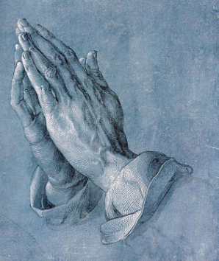

theway church
david s. wilson
June 12, 2016

Jude 20-23 But you, beloved, building yourselves up on your most holy faith, praying in the Holy Spirit, 21 keep yourselves in the love of God, looking for the mercy of our Lord Jesus Christ unto eternal life. 22 And on some have compassion, making a distinction; 23 but others save with fear, pulling them out of the fire, hating even the garment defiled by the flesh.

Jude’s Bodybuilding Tips

1. Faith
20 But you, beloved, building yourselves up on your most
holy faith…

2. Prayer
20 But you, beloved, building yourselves up on your most
holy faith, praying in the Holy Spirit,

3. Love
21 keep yourselves in the love of God…
4. Mercy
21 keep yourselves in the love of God, looking for the
mercy of our Lord Jesus Christ unto eternal life.

5. Compassion
22 And on some have compassion, making a distinction…

6. Fear
22 And on some have compassion, making a distinction;
23 but others save with fear…

7. Truth
23 but others save with fear, pulling them out of the fire,
hating even the garment defiled by the flesh.

